**Login Page**

The first page you see when you open the program.  The left side shows the login box, where you enter your user information to access your Desktop.

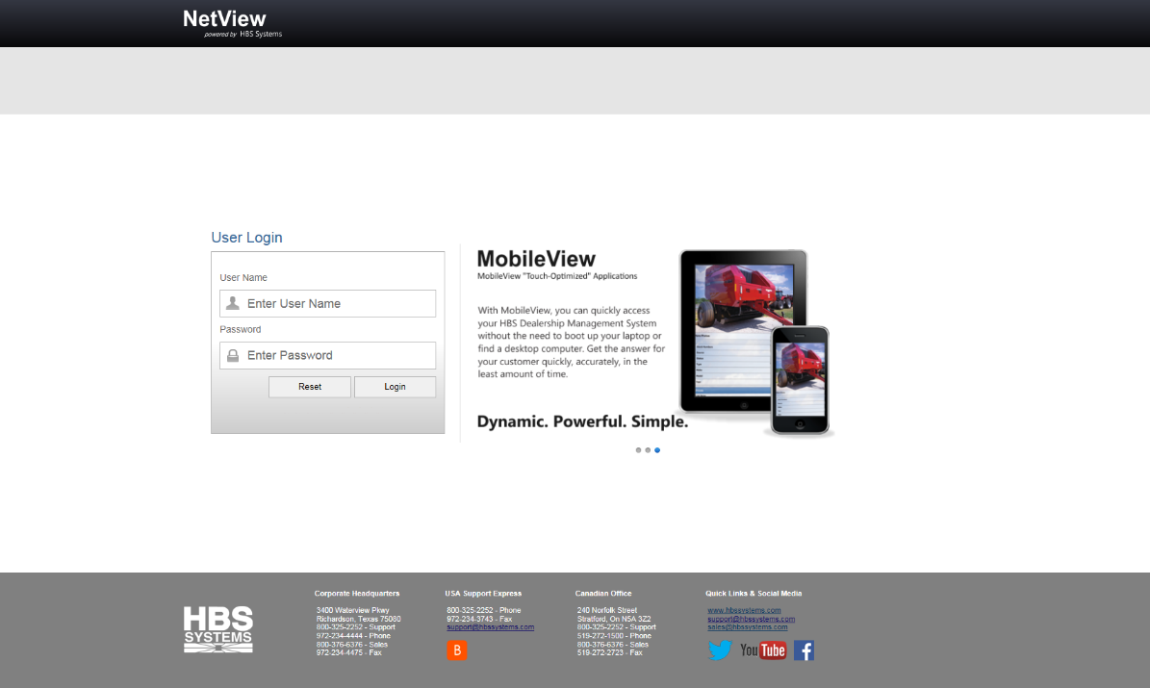

**Logging In:** To log in, type in your user name and password in the appropriate fields, then click **Login**.

* **To clear the fields,** click **Reset**.
* If you are **having trouble logging in:**
  + Make sure both your user name and password are correct.
  + Make sure you have typed your user name in the field labeled “User Name” and your password in the field labeled “Password.”
  + You can try **3 times** to type your information in.  After the third failed try, the system will not let you log in for 15-30 seconds.  When that time has passed, you may try again.
  + **If you have forgotten your user name and/or password, contact your system administrator.**

**Contacting HBS Systems:** Contact information for HBS Systems and relevant web links are located at the bottom of the Login Page.



* Under the **Corporate Headquarters** heading, you will the find addresses and phone/fax numbers for the main office.
* Under the **USA Support Express** heading, you will find the phone/fax numbers and email address for USA Support.  There is also a link to the **Bomgar™ Support Portal**.
* Under the **Canadian Office** heading, you will find the addresses and phone/fax numbers for the Canadian office.
* Under the **Quick Links & Social Media** heading, you can access the HBS main website, email Support and Sales, and access HBS’s social media pages.